**Anchor**

Anchor tags are similar to a TouchSensor in that clicking on them invokes interactivity. The interactivity is limited to: going to another <Viewpoint> node, opening up a web page, or loading a new X3D file.

Anchor tags do not require ROUTE’s or Script nodes since; their interactivity is limited.

**anchor_webPages.x3d**

Demonstrates opening up a web page. There are several strings of text in the scene: ‘WSJ’, ‘WSJ RSS’, ‘People’, and a Sphere with a texture map.

‘WSJ’ text opens up the Wall Street Journal’s web page, though the web page version redirected to their mobile web page (not shown below).

‘WSJ RSS’ is the RSS feed. Really Simple Sindication, an XML format, is for news sources on the web. GearVR X3D implementation uses CSS (Cascading Style Sheets) to format the web page.

‘People’ open People magazine web site. The textured sphere opens the SIGGRAPH Conference 2017 web page. Clicking on the web page will close it.

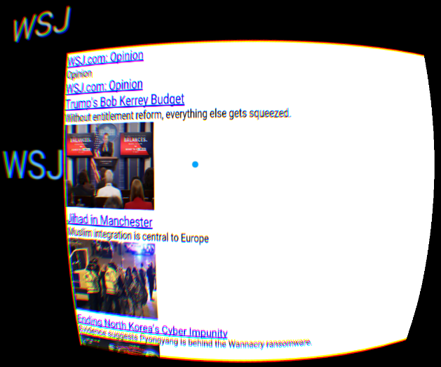

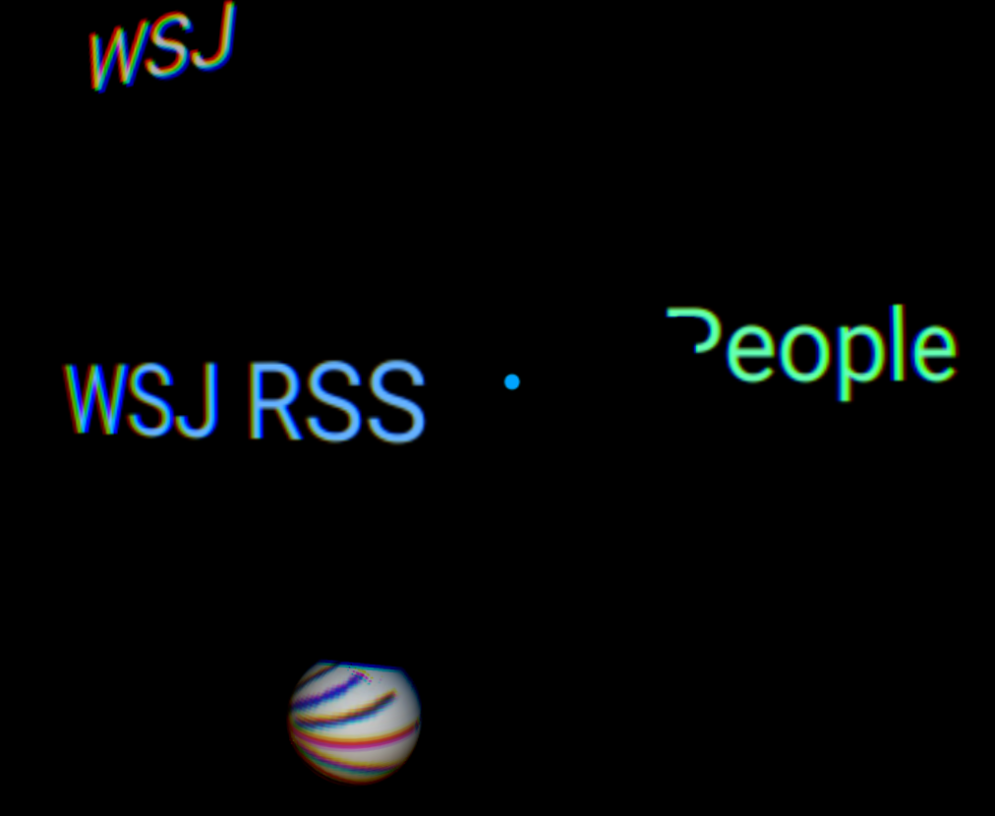

 

**anchor_viewpoint.x3d**

If the Anchor tag url begins with a ‘#’ pound sign, it will go that Viewpoint (camera) by the same name.

Opening scene has the camera at (0,0,0). Clicking on the green Cone positions the Camera to Viewpoint ‘vp2’ at (0,0,15). Clicking the orange Sphere positions the Camera to Viewpoint ‘vp3’ located at (0, 0, 7). Due to cropping the images, the new scene actually looks the same as this.

Clicking the light blue Cylinder positions the Camera to Viewpoint ‘vp4’ located at (0, 0, -8). The blue Cylinder is visible at the top since it is at (0, 3, -10) and the orange Sphere is at (0, 0, -20).

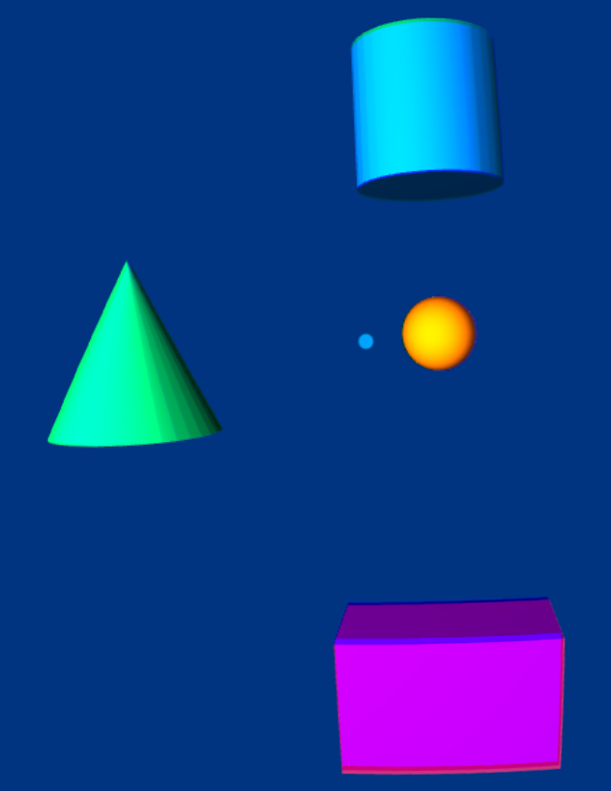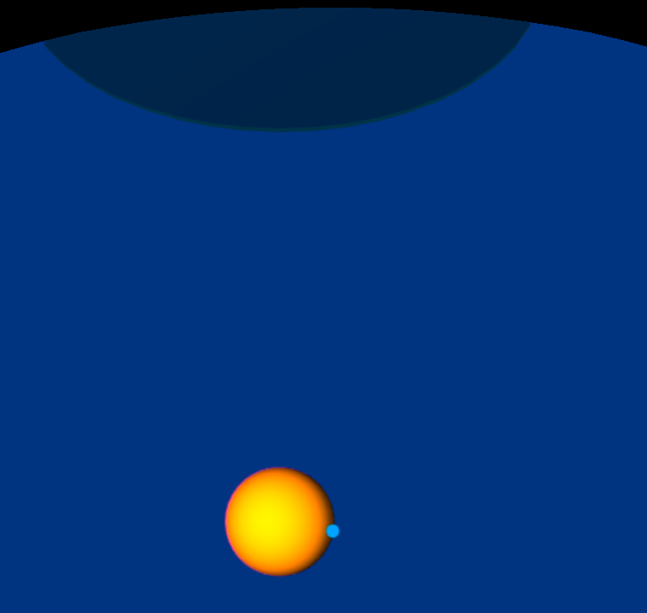

Clicking the magenta Box positions the Camera to Viewpoint ‘vpLeft’ at (-10, -5, -10). Initially, we will be looking at a blank background because GearVR ignores the Viewpoint’s orientation. But looking right 90 degrees shows the scene including the flat textured plane.

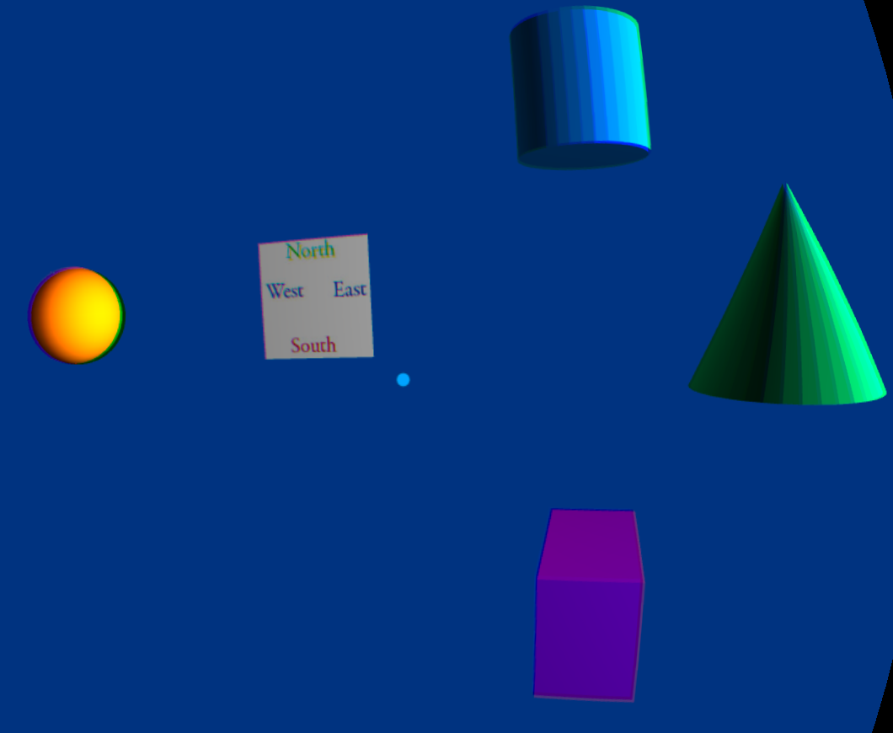

**anchonewX3DFile_viewpoints.x3d with animationAfterAchor.x3d**

Anchors can load a new X3D scene. Clicking on the yellow Sphere loads the new ‘animationAfterAnchor.x3d’ file. Marker ONE textured plane is also animated with both objects rotated about 45 degrees counter-clockwise.

